**A**

**FINAL YEAR PROJECT REPORT**

**ON**

**“ULTRASONIC RADAR MODEL”**

***Submitted in partial fulfilment of the requirement for the degree of***

**Bachelor of Engineering**

**In**

**Electronics and Communication Engineering**



***Guided By***

**Mrs ANSUYA BOHRA**

***Submitted By***

**PUSHPENDRA CHOUDHARY**

**Roll No.: 20UECE7025**

**Enrolment No.:****19R/43940**

**Department of Electronics and Communication Engineering**

**M.B.M. University**

**Jodhpur-342011**

**2022-23**

**CERTIFICATE**

This is to certify that this seminar report titled **Neuralink – Brain Computer Interface** has been submitted by **Pushpendra Choudhary (19R/43940)** in partial fulfillment of the requirements for the degree of Bachelor of Engineering in **Electronics & Communication Engineering** of the MBM Engineering College, JNVU, Jodhpur during the academic year **2022-23** and is a record of study applied by him/her under my guidance and supervision.

______________________

**Mrs Ansuya Bohra** Date:

Department of Electronics & Communication Engineering,

M.B.M University, Jodhpur

**ACKNOWLEDGEMENT**

We would like to express our sincere appreciation to everyone who has supported us in the development and completion of our **Ultrasonic Radar Model**. This project required the expertise and assistance of many individuals, and we are grateful for their contributions

Firstly, we would like to thank our supervisor Mrs. Ansuya Bohra, for their guidance, support, and encouragement throughout the project. Their extensive knowledge and expertise in the field of ultrasonic radar technology were invaluable in helping us to develop our project and overcome technical challenges.

We would also like to thank the faculty members of Department of Electronics and Communication, M.B.M. University, for providing us with access to the resources and equipment necessary to conduct our research. The department's facilities, including the laboratory and workshop, were essential in the development and testing of our ultrasonic radar model.

We would also like to acknowledge the support of the participants who helped us to test our ultrasonic radar model. Their time and feedback were invaluable in improving the functionality and accuracy of our model.

Finally, we would like to express our gratitude to each member of our team. Our collaboration and teamwork were crucial in the success of our project. Each member's individual expertise and contribution were vital in developing our ultrasonic radar model.

Once again, we extend our heartfelt thanks to everyone who has supported us in the development and completion of our ultrasonic radar model project. We are grateful for your assistance and contributions to our success.

**ABSTRACT**

This project presents an ultrasonic radar model that utilizes an ultrasonic sensor, an ATmega328 microcontroller, and a display unit to detect objects and display their distance, angle, and speed on an LCD screen. The model is designed to detect objects within a range of up to 5 meters and provide real-time data on their position and movement.

The model operates by emitting ultrasonic waves that bounce back when they hit an object. The sensor measures the time taken for the waves to return and calculates the distance, angle, and speed of the object. The data is then processed by the ATmega328 microcontroller, which controls the servo motor to rotate the sensor and provide a complete scan of the surroundings.

The ultrasonic radar model's graphical user interface displays the detected object's distance, angle, and speed on the LCD screen. The display unit provides a visual representation of the surrounding area, making it easy to identify the object's position and movement.

The model is portable, low-cost, and easy to operate, making it suitable for a wide range of applications, including robotics, security systems, and autonomous vehicles. The ultrasonic radar model's accuracy, versatility, and ease of use make it a valuable addition to the field of ultrasonic radar technology.

In conclusion, the ultrasonic radar model presented in this project provides a simple and efficient solution to the problem of object detection and location, with applications in various fields. The model's design and performance showcase the potential of ultrasonic radar technology and its ability to improve real-world applications.

**LIST OF FIGURES**

**TABLE OF CONTENTS**

**Certificate** i

**Acknowledgement** ii

**Abstract** iii

**Table of Contents** iv

**Chapter-1 Introduction** 1

* 1. Definitions 1
  2. History 2

1.3 Technology 4

1.3.1 Probes 4

1.3.2 Robot 5

1.3.3 Electronics 5

**Chapter-2 Literature Review 6**

2.1 BCI input and output 6

2.1.1 Sensory Input 7

2.1.2 BCI drawbacks and innovator 8

2.1.3 Animal BCI research 9

2.1.4 Human BCI research 11

2.2 Working of Neuralink 14

2.2.1 What Neuralink does? 15

2.3 Installation process 16

**Chapter-3 Application and Limitations** 17

3.1 Applications 17

3.1.1 For visuals Prosthesis 17

3.1.2 For Telepathy 17

3.1.3 As an Oscilloscope for Brain 18

3.1.4 Nostalgia on demand 18

3.1.5 Eliminate Pain 18

3.1.6 AI symbiosis 18

3.1.7 Consciousness through the lens of physics 19

3.1.8 Disease prediction 19

3.2 Effect of Neuralink on life of human beings 19

3.2.1 Effect on the World Education 19

3.2.2 Effect in the World Medicine 21

3.2.3 Effect to the Human Social life 21

3.2.4 Effect to the religious matter 22

3.2.5 Effect to the Legal Positivism 23

**Chapter-4 Conclusion** 25

4.1 How does the Neuralink System Differ from other BCI devices? 25

4.1.1 Will the link be safe? 25

4.2 Ethical Consideration 26

4.3 Conclusion 27

**Appendix** 29

**References** 31

CHAPTER 1

**INTRODUCTION**

Since 2017, Elon Musk’s project Neuralink and brain-machine interfaces have received a lot of attention. Neuralink is a brain machine interface (BMI) company that creates devices designed to be implanted in human brains "to eventually improve memory and interface with computer systems."

On August 28, 2020, billionaire entrepreneur Elon Musk presented his pig Gertrude and the chip implanted in the animal’s brain. The chip retransmits Gertrude’s neurological signals. From this information, a computer can predict at any time where each of Gertrude’s members is, giving hope to restore mobility to paraplegic people. Elon Musk is brilliant at marketing his ideas on a large scale and creating enthusiasm and fascination for his various projects. Never short of vivid images, Elon Musk claimed that having the interface comparable to have a smart watch in your brain. Science expands and brings new technologies, which leads to benefits, but also threats, as society’s relationships are reshaped.

For this study, it was of interest to investigate Neuralink, BMIs, and Transhumanism, which are both fascinating and frightening. Scientists need to ensure that the benefits are maximized while minimizing the threats.

* 1. DEFINITIONS

Neuralink is a device that will be surgically implanted into your brain and with it, you’ll be able to communicate with machines and even control them. It will also help study the electrical signals in the brain and arrive at solutions that can help cure various medical problems. The company was founded in 2016 and has been working in developing this technology ever since. According to Elon Musk, the team is optimistic of introducing the technology by the end of 2020, although human trials have not yet started. With Neuralink a chipset, called N1 chipset will be installed in your skull which is 8mm in diameter and has multiple wires housing electrodes and insulation for the wires. These wires will be surgically placed inside your brain using a robot. As per the company, the wire is as thick as the neurons in your brain and thinner than a strand of hair at 100 micrometers. To compare, imagine the diameter of your hair, and then divide that diameter by ten. Max Honda, the president of Neuralink, says that you can place more than one device to target different sections of your brain. So basically, Neuralink is a type of Brain computer interface which will discuss in detail in further chapters.

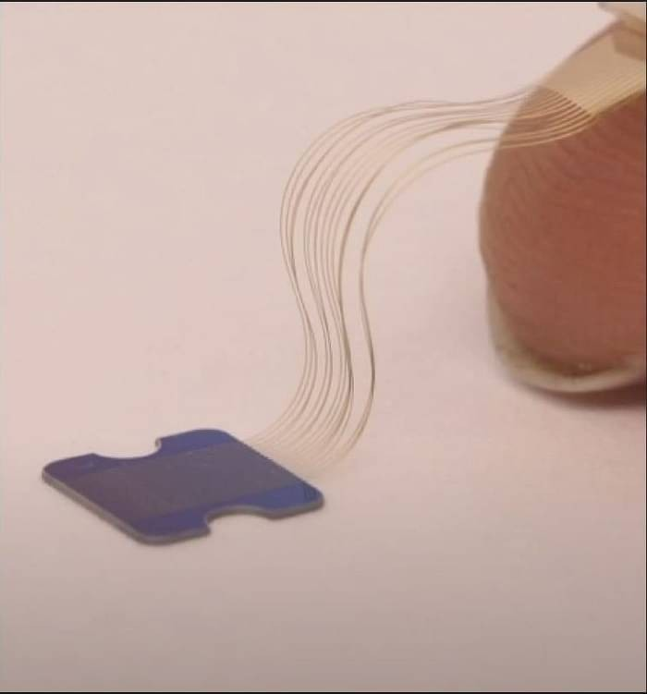

Figure 1: the size of the Neuralink chip as compared to the little finger of the hand

* 1. **HISTORY**

Hans Berger’s innovation in the field of human brain research and its electrical activity has a close connection with the discovery of brain computer interfaces. Berger is credited with the development of electroencephalography, which was a major breakthrough for humans and helped researchers record human brain activity – the electroencephalogram (EEG). This was certainly a major discovery in human brain mapping, which made it possible to detect brain diseases. Richard Canton’s 1875’s discovery of electrical signals in animal brains was an inspiration for Berger. As one of the first common use of brain computer interface technology, EEG neurofeedback has been in use for several decades.

The year 1998 marked a significant development in the field of brain mapping when researcher Philip Kennedy implanted the first brain computer interface object into a human being. However, the BCI object was of limited function. The only benefit from this development was the use of a wireless di-electrode.

John Donoghue and his team of Brown University researchers formed a public traded company, Cyberkinetics, in 2001. The goal was to commercially design a brain computer interface, the so-called Brain Gate. The company has come up with NeuroPort its first commercial product. Columbia University Medical Centre researchers have successfully monitored and recorded electrical activity in the brain with improved precision. According to researchers, NeuroPort Neural Monitoring System enabled them to identify micro-seizure activity prior to epileptic seizures among patients.

June 2004 marked a significant development in the field when Matthew Nagle became the first human to be implanted with a BCI, Cyberkinetics’s BrainGate.

In December 2004, Jonathan Wolgan and researchers at New York State Department of Health’s Wadsworth Centre came up with a research report that demonstrated the ability to control a computer using a BCI. In the study, patients were asked to wear a cap that contained electrodes to capture EEG signals from the motor cortex – part of the cerebrum governing movement. And this Neuralink is a part of BCI’s technology.

Neuralink was founded in 2016 by Elon Musk and a founding team of seven other scientists and engineers. The group of initial hires consisted of experts in areas such as neuroscience, biochemistry and robotics. The trademark "Neuralink" was purchased from its previous owners in January 2017.

In April 2017, Neuralink announced that it was aiming to make devices to treat serious brain diseases in the short-term, with the eventual goal of human enhancement, sometimes called transhumanism. Musk had said his interest in the idea partly stemmed from the science fiction concept of "neural lace" in the fictional universe in *The Culture*, a series of 10 novels by Iain M. Banks.

Musk defined the neural lace as a "digital layer above the cortex" that would not necessarily imply extensive surgical insertion but ideally an implant through a vein or artery. He said the long-term goal is to achieve "symbiosis with artificial intelligence", which he perceives as an existential threat to humanity if it goes unchecked. He believes the device will be "something analogous to a video game, like a saved game situation, where you are able to resume and upload your last state" and "address brain injuries or spinal injuries and make up for whatever lost capacity somebody has with a chip."

As of 2020, Neuralink is headquartered in San Francisco's Mission District, sharing the Pioneer building with OpenAI, another company co-founded by Musk. Jared Birchall, the head of Musk's family office, was listed as CEO, CFO and president of Neuralink in 2018. As of September 2018, Musk was the majority owner of Neuralink but did not hold an executive position.

By August 2020, only three of the eight founding scientists remained at the company, according to an article by Stat News which reported that Neuralink had seen "years of internal conflict in which rushed timelines have clashed with the slow and incremental pace of science."

In April 2021, Neuralink demonstrated a monkey playing the game "Pong" using the Neuralink implant. While similar technology has existed since 2002, when a research group first demonstrated a monkey moving a computer cursor with neural signals, scientists acknowledged the engineering progress in making the implant wireless and increasing the number of implanted electrodes.

In May 2021, co-founder and President Max Hodak announced that he no longer works with the company. As of January 2022, of the eight cofounders, only two remain at the company.

* 1. TECHNOLOGY

In 2018, Gizmodo reported that Neuralink "remained highly secretive about its work", although public records showed that it had sought to open an animal testing facility in San Francisco; it subsequently started to carry out research at the University of California, Davis. In 2019, during a live presentation at the California Academy of Sciences, the Neuralink team revealed to the public the technology of the first prototype they had been working on. It is a system that involves ultra-thin probes that will be inserted into the brain, a neurosurgical robot that will perform the operations and a high-density electronic system capable of processing information from neurons. It is based on technology developed at UCSF and UC Berkeley.

**1.3.1 Probes:** The probes, composed mostly of polyimide, a biocompatible material, with a thin gold or platinum conductor, are inserted into the brain through an automated process performed by a surgical robot. Each probe consists of an area of wires that contains electrodes capable of locating electrical signals in the brain, and a sensory area where the wire interacts with an electronic system that allows amplification and acquisition of the brain signal. Each probe contains 48 or 96 wires, each of which contains 32 independent electrodes, making a system of up to 3072 electrodes per formation.

**1.3.2 Robot:** Neuralink says they have engineered a surgical robot capable of rapidly inserting many flexible probes into the brain, which may avoid the problems of tissue damage and longevity issues associated with larger and more rigid probes. This surgical robot has an insertion head with a 40μm diameter needle made of tungsten-rhenium designed to attach to the insertion loops, inject individual probes, and penetrate the meninges and cerebral tissue; it is capable of inserting up to six wires (192 electrodes) per minute.

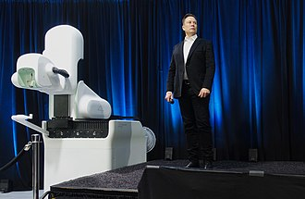**1.3.3 Electronics:** Neuralink has developed an Application-Specific Integrated Circuit (ASIC) to create a 1,536-channel recording system. This system consists of 256 amplifiers capable of being individually programmed ("analog pixels"), analog-to-digital converters within the chip ("ADCs") and a peripheral circuit control to serialize the digitized information obtained. It aims to convert information obtained from neurons into an understandable binary code in order to achieve greater understanding of brain function and the ability to stimulate these neurons back. With the present technology, electrodes are still too big to record the firing of individual neurons, so they can record only the firing of a group of neurons; Neuralink representatives believe this issue might get mitigated algorithmically, but it is computationally expensive and does not produce exact results.

Figure 2: Elon Musk discussing the Neuralink

**CHAPTER 2**

**LITERATURE REVIEW**

**2.1 BCI INPUT AND OUTPUT**

One of the biggest challenges facing brain-computer interface researchers today is the basic mechanics of the interface itself. The easiest and least invasive method is a set of electrodes -- a device known as an electroencephalograph (EEG) -- attached to the scalp. The electrodes can read brain signals. However, the skull blocks a lot of the electrical signal, and it distorts what does get through.

To get a higher-resolution signal, scientists can implant electrodes directly into the gray matter of the brain itself, or on the surface of the brain, beneath the skull. This allows for much more direct reception of electric signals and allows electrode placement in the specific area of the brain where the appropriate signals are generated. This approach has many problems, however. It requires invasive surgery to implant the electrodes, and devices left in the brain long-term tend to cause the formation of scar tissue in the gray matter. This scar tissue ultimately blocks signals. Regardless of the location of the electrodes, the basic mechanism is the same: The electrodes measure minute differences in the voltage between neurons. The signal is then amplified and filtered. In current BCI systems, it is then interpreted by a computer program, although you might be familiar with older analogue encephalographs, which displayed the signals via pens that automatically wrote out the patterns on a continuous sheet of paper.

In the case of a sensory input BCI, the function happens in reverse. A computer converts a signal, such as one from a video camera, into the voltages necessary to trigger neurons. The signals are sent to an implant in the proper area of the brain, and if everything works correctly, the neurons fire and the subject receive a visual image corresponding to what the camera sees. Another way to measure brain activity is with a Magnetic Resonance Image (MRI). An MRI machine is a massive, complicated device. It produces very high-resolution images of brain activity, but it can't be used as part of a permanent or semi-permanent BCI. Researchers use it to get benchmarks for certain brain functions or to map where in the brain electrodes should be placed to measure a specific function. For example, if researchers are attempting to implant electrodes that will allow someone to control a robotic arm with their thoughts, they might first put the subject into an MRI and ask him or her to think about moving their actual arm. The MRI will show which area of the brain is active during arm movement, giving them a clearer target for electrode placement.

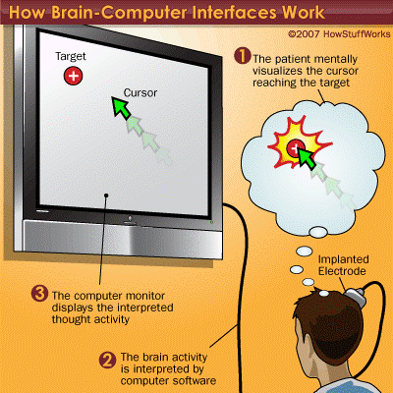

Fig 3: How Brain-Computer Interface Work

A similar method is used to manipulate a computer cursor, with the subject thinking about forward, left, right and back movements of the cursor. With enough practice, users can gain enough control over a cursor to draw a circle, access computer programs and control a TV.

It could theoretically be expanded to allow users to "type" with their thoughts.

Once the basic mechanism of converting thoughts to computerized or robotic action is perfected, the potential uses for the technology are almost limitless. Instead of a robotic hand, disabled users could have robotic braces attached to their own limbs, allowing them to move and directly interact with the environment.

This could even be accomplished without the "robotic" part of the device. Signals could be sent to the appropriate motor control nerves in the hands, bypassing a damaged section of the spinal cord and allowing actual movement of the subject's own hands.

On the next page we'll learn about cochlear implants and artificial eye development [21].

**2.1.1 Sensory Input**

The most common and oldest way to use a BCI is a cochlear implant. For the average person, sound waves enter the ear and pass through several tiny organs that eventually pass the vibrations on to the auditory nerves in the form of electric signals. If the mechanism of the ear is severely damaged, that person will be unable to hear anything. However, the auditory nerves may be functioning perfectly well. They just aren't receiving any signals.

A cochlear implant bypasses the non-functioning part of the ear, processes the sound waves into electric signals and passes them via electrodes right to the auditory nerves. The result: A previously deaf person can now hear. He might not hear perfectly, but it allows him to understand conversations.

The processing of visual information by the brain is much more complex than that of audio information, so artificial eye development isn't as advanced. Still, the principle is the same. Electrodes are implanted in or near the visual cortex, the area of the brain that processes visual information from the retinas. A pair of glasses holding small cameras is connected to a computer and, in turn, to the implants. After a training period similar to the one used for remote thought-controlled movement, the subject can see. Again, the vision isn't perfect, but refinements in technology have improved it tremendously since it was first attempted in the 1970s. Jens Naumann was the recipient of a second-generation implant. He was completely blind, but now he can navigate New York City's subways by himself and even drive a car around a parking lot. In terms of science fiction becoming reality, this process gets very close. The terminals that connect the camera glasses to the electrodes in Naumann’s brain are similar to those used to connect the VISOR (Visual Instrument and Sensory Organ) worn by blind engineering officer Geordi La Forge in the "Star Trek: The Next Generation" TV show and films, and they're both essentially the same technology. However, Naumann isn't able to "see" invisible portions of the electromagnetic spectrum [19].

**2.1.2 BCI Drawbacks And Innovator**

Although we already understand the basic principles behind BCIs, they don't work perfectly. There are several reasons for this.

The brain is incredibly complex. To say that all thoughts or actions are the result of simple electric signals in the brain is a gross understatement. There are about 100 billion neurons in a human brain [source: Greenfield]. Each neuron is constantly sending and receiving signals through a complex web of connections. There are chemical processes involved as well, which EEGs can't pick up on.

The signal is weak and prone to interference. EEGs measure tiny voltage potentials. Something as simple as the blinking eyelids of the subject can generate much stronger signals. Refinements in EEGs and implants will probably overcome this problem to some extent in the future, but for now, reading brain signals is like listening to a bad phone connection. There's lots of static.

The equipment is less than portable. It's far better than it used to be -- early systems were hardwired to massive mainframe computers. But some BCIs still require a wired connection to the equipment, and those that are wireless require the subject to carry a computer that can weigh around 10 pounds. Like all technology, this will surely become lighter and more wireless in the future.

A few companies are pioneers in the field of BCI. Most of them are still in the research stages, though a few products are offered commercially.

Neural Signals is developing technology to restore speech to disabled people. An implant in an area of the brain associated with speech (Broca's area) would transmit signals to a computer and then to a speaker. With training, the subject could learn to think each of the 39 phonemes in the English language and reconstruct speech through the computer and speaker.

NASA has researched a similar system, although it reads electric signals from the nerves in the mouth and throat area, rather than directly from the brain. They succeeded in performing a Web search by mentally "typing" the term "NASA" into Google.

CyberKinetics Neurotechnology Systems is marketing the BrainGate, a neural interface system that allows disabled people to control a wheelchair, robotic prosthesis or computer cursor.

Japanese researchers have developed a preliminary BCI that allows the user to control their avatar in the online world Second Life [20].

**2.1.3 Animal BCI Research**

Several laboratories have managed to record signals from monkey and rat cerebral cortices to operate BCIs to produce movement. Monkeys have navigated computer cursors on screen and commanded robotic arms to perform simple tasks simply by thinking about the task and seeing the visual feedback, but without any motor output. In May 2008 photographs that showed a monkey at the University of Pittsburgh Medical Centre operating a robotic arm by thinking were published in a number of well-known science journals and magazines. Other research on cats has decoded their neural visual signals.

In 1969 the operant conditioning studies of Fetz and colleagues, at the Regional Primate Research Center and Department of Physiology and Biophysics, University of Washington School of Medicine in Seattle, showed for the first time that monkeys could learn to control the deflection of a biofeedback meter arm with neural activity. Similar work in the 1970s established that monkeys could quickly learn to voluntarily control the firing rates of individual and multiple neurons in the primary motor cortex if they were rewarded for generating appropriate patterns of neural activity.

Studies that developed algorithms to reconstruct movements from motor cortex neurons, which control movement, date back to the 1970s. In the 1980s, Apostolos Georgopoulos at Johns Hopkins University found a mathematical relationship between the electrical responses of single motor cortex neurons in rhesus macaque monkeys and the direction in which they moved their arms (based on a cosine function). He also found that dispersed groups of neurons, in different areas of the monkey's brains, collectively controlled motor commands, but was able to record the firings of neurons in only one area at a time, because of the technical limitations imposed by his equipment.

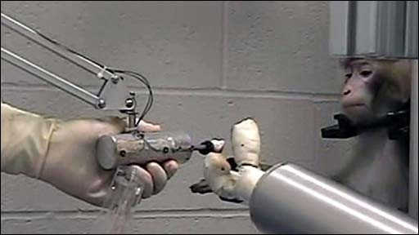There has been rapid development in BCIs since the mid-1990s.Several groups have been able to capture complex brain motor cortex signals by recording from neural ensembles (groups of neurons) and using these to control external devices [24].

Fig. 4: Monkey operating a robotic arm with brain–computer interfacing (Schwartz lab, University of Pittsburgh)

**2.1.4 Human BCI Research**

**2.1.4.1 Invasive BCIs**

**Vision:**

Invasive BCI research has targeted repairing damaged sight and providing new functionality for people with paralysis. Invasive BCIs are implanted directly into the grey matter of the brain during neurosurgery. Because they lie in the grey matter, invasive devices produce the highest quality signals of BCI devices but are prone to scar-tissue build-up, causing the signal to become weaker, or even non-existent, as the body reacts to a foreign object in the brain.

In vision science, direct brain implants have been used to treat non-congenital (acquired) blindness. One of the first scientists to produce a working brain interface to restore sight was private researcher William Dobelle.

Dobelle's first prototype was implanted into "Jerry", a man blinded in adulthood, in 1978. A single-array BCI containing 68 electrodes was implanted onto Jerry’s visual cortex and succeeded in producing phosphenes, the sensation of seeing light. The system included cameras mounted on glasses to send signals to the implant. Initially, the implant allowed Jerry to see shades of grey in a limited field of vision at a low frame-rate. This also required him to be hooked up to a mainframe computer, but shrinking electronics and faster computers made his artificial eye more portable and now enable him to perform simple tasks unassisted.

In 2002, Jens Naumann, also blinded in adulthood, became the first in a series of 16 paying patients to receive Dobelle’s second generation implant, marking one of the earliest commercial uses of BCIs. The second-generation device used a more sophisticated implant enabling better mapping of phosphenes into coherent vision. Phosphenes are spread out across the visual field in what researchers call "the starry- night effect". Unfortunately, Dr. Dobelle died in 2004 before his processes and developments were documented. Subsequently, when Mr. Naumann and the other patients in the program began having problems with their vision, there was no relief and they eventually lost their "sight" again. Mr. Naumann wrote about his experience with Dr. Dobelle's work in Search for Paradise: A Patient's Account of the Artificial Vision Experiment and has returned to his farm in Southeast Ontario, Canada, to resume his normal activities. So **Neuralink consists of invasive electrodes.**

**Movement:**

BCIs focusing on motor neuroprosthetics aim to either restore movement in individuals with paralysis or provide devices to assist them, such as interfaces with computers or robot arms.

Researchers at Emory University in Atlanta, led by Philip Kennedy and Roy Bakay, were first to install a brain implant in a human that produced signals of high enough quality to simulate movement. Their patient, Johnny Ray (1944–2002), suffered from ‘locked-in syndrome’ after suffering a brain-stem stroke in 1997. Ray’s implant was installed in 1998 and he lived long enough to start working with the implant, eventually learning to control a computer cursor; he died in 2002 of a brain aneurysms.

Tetraplegia Matt Nagle became the first person to control an artificial hand using a BCI in 2005 as part of the first nine-month human trial of Cyberkinetics’s BrainGate chip-implant. Implanted in Nagle’s right precentral gyrus (area of the motor cortex for arm movement), the 96-electrode BrainGate implant allowed Nagle to control a robotic arm by thinking about moving his hand as well as a computer cursor, lights and TV.

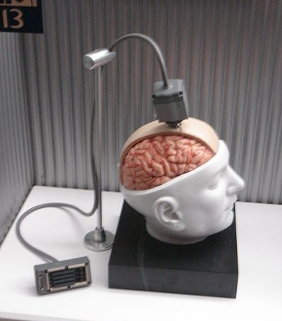

Fig 5: Dummy unit illustrating the design of a BrainGate interface

More recently, research teams led by the Braingate group at Brown University and a group led by University of Pittsburgh Medical Center, both in collaborations with the United States Department of Veterans Affairs, have demonstrated further success in direct control of robotic prosthetic limbs with many degrees of freedom using direct connections to arrays of neurons in the motor cortex of patients with tetraplegia [24].

**2.1.4.2 Partially invasive BCIs**

Partially invasive BCI devices are implanted inside the skull but rest outside the brain rather than within the grey matter. They produce better resolution signals than non- invasive BCIs where the bone tissue of the cranium deflects and deforms signals and have a lower risk of forming scar-tissue in the brain than fully invasive BCIs.

**Electrocorticography (ECoG)** measures the electrical activity of the brain taken from beneath the skull in a similar way to non-invasive electroencephalography (see below), but the electrodes are embedded in a thin plastic pad that is placed above the cortex, beneath the duramater. ECoG technologies were first trailed in humans in 2004 by Eric Leuthardt and Daniel Moran from Washington University in St Louis. In a later trial, the researchers enabled a teenage boy to play Space Invaders using his Eco implant. This research indicates that control is rapid, requires minimal training, and may be an ideal trade off with regards to signal fidelity and level of invasiveness. (Note: these electrodes had not been implanted in the patient with the intention of developing a BCI. The patient had been suffering from severe epilepsy and the electrodes were temporarily implanted to help his physicians localize seizure foci; the BCI researchers simply took advantage of this.)

Signals can be either subdural or epidural, but are not taken from within the brain parenchyma itself. It has not been studied extensively until recently due to the limited access of subjects. Currently, the only manner to acquire the signal for study is through the use of patients requiring invasive monitoring for localization and resection of an epileptogenic focus.

ECoG is a very promising intermediate BCI modality because it has higher spatial resolution, better signal-to-noise ratio, wider frequency range, and less training requirements than scalp-recorded EEG, and at the same time has lower technical difficulty, lower clinical risk, and probably superior long-term stability than intracortical single-neuron recording. This feature profile and recent evidence of the high level of control with minimal training requirements shows potential for real world application for people with motor disabilities.

Light Reactive Imaging BCI devices are still in the realm of theory. These would involve implanting a laser inside the skull. The laser would be trained on a single neuron and the neuron's reflectance measured by a separate sensor. When the neuron fires, the laser light pattern and wavelengths it reflects would change slightly. This would allow researchers to monitor single neurons but require less contact with tissue and reduce the risk of scar-tissue build-up.

**2.1.4.3 Non-Invasive Electrodes**

As well as invasive experiments, there have also been experiments in humans using non-invasive neuroimaging technologies as interfaces. Signals recorded in this way have been used to power muscle implants and restore partial movement in an experimental volunteer.

Although they are easy to wear, non-invasive implants produce poor signal resolution because the skull dampens signals, dispersing and blurring the electromagnetic waves created by the neurons. Although the waves can still be detected it is more difficult to determine the area of the brain that created them or the actions of individual neurons. Now after getting the knowledge regarding different types of BCI lets go to working of Neuralink [22].

**2.2 WORKING OF NEURALINK**

Before understanding how does Neuralink work, it is best to comprehend the science behind the human brain. The brain consists of neurons that transmit signals to cells in the body including muscle, nerve, gland and other neuron cells. Every neuron is made up of three parts called the dendrite, the soma (cell body) and the axon. Each of this part has its own function. The dendrite receives the signals. The soma processes these signals. The axon then transmits the signals to the other cells. The neurons are connected to one another by the synapses which release neurotransmitters. These chemical substances are then sent to another neuron cell’s dendrite causing the flow of current across the neurons. The electrodes that are part of the Neuralink will read electrical signals that are produced by several neurons in the brain. The signals are then outputted in form of an action or movement. According to the company’s website, the device is implanted directly in the brain because placing it outside the head will not detect the signals produced by the brain accurately. Now that you know what Neuralink is and how it works, get to know what does Neuralink do [20].

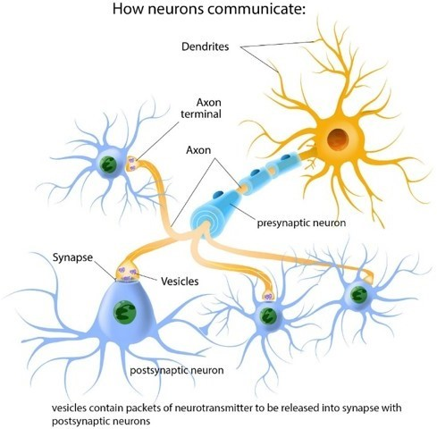

Fig 6: How Neurons Communicate

**2.2.1 What Neuralink Does?**

Neuralink can be used to operate encephalopathy. It can also be used as a connection between the human brain and technology. This means that people with paralysis can easily operate their phones and computer directly with their brain. Its main purpose is to help people to communicate through text or voice messages. Of course, Neuralink is not limited to that, it can also be utilized to draw pictures, take photographs and do other activities. The goal of the N1 chip is to record and stimulate electrical spikes inside your brain. You’ll also be able to learn different skills using a dedicated app. At the moment it is not clear whether Bluetooth or some other form of technology will be used to relay the data but it is certain that process is going to be wireless[20].

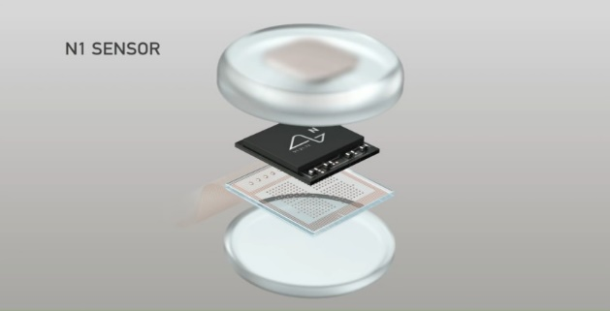

Fig 7: N1 Sensor exploded view showing all the components

**2.3 INSTALLATION PROCESS**

Since we’re talking about drilling a hole into your skull and inserting wires into your brain there are a lot of reservations among people.

Musk has said that the procedure is complex and beyond the capabilities of even skilled human hands.

Which is why Neuralink will be using its specially developed robots to carry out the quick and precise insertion of the device into the cortex? The company said it will work in accordance with the regulations by health ministries while carrying out the operation to ensure it is safe.

The Neuralink robot will insert the module into your brain using a microscope and needles the size of 24 microns (a micron is one-millionth of a meter). These needles are so small that you can't easily spot them with the naked eye.

As per the company, there could be 10,000 electrodes inserted into the brain.

The robot has been designed to ensure that the device is inserted into the brain without touching any veins or arteries. Each electrode will be inserted specifically bypassing any kind of blood vessel.

The operation will require a 2mm incision which will be dilated up to 8mm. After the procedure is complete the exposed part of the skull will be covered with the chipset module. The installation procedure could take up to two hours according to Musk and the person could also be under partial anesthesia during the process. He also said that there won’t be any wires or antennas coming out of your head after the device have been installed [20].

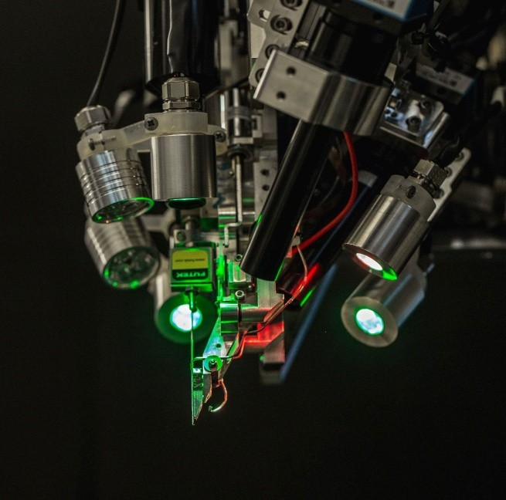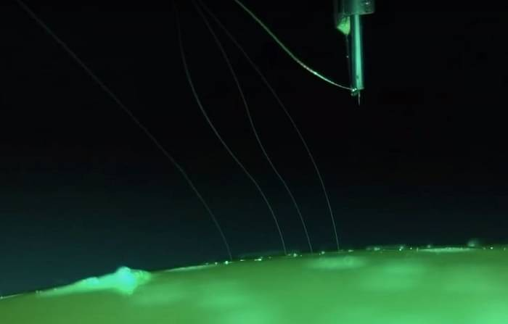

Fig 8 Fig 9

**CHAPTER 3**

**APPLICATIONS AND LIMITATIONS**

**3.1 APPLICATIONS**

Towards the end of the Neuralink event, a handful of team members from different disciplines answered most interesting questions from the Internet. They took turns and expressed what kind of applications excite them the most and shared what they expect to see from Neuralink in the future.

**3.1.1 for Visual Prosthesis**

One of the engineers at Neuralink who works in the visual neuroscience department said that this project has the potential to provide a visual prosthesis for people who have retinal injury or blindness through eye injury. The idea is to essentially plug a camera directly into the visual cortex and stimulate an enormous array of thousands or maybe tens of thousands of electrodes to recreate a visual image. And in time perhaps the same technology can be used to produce some kind of heads-up display. To this Elon Musk added that we could actually give somebody supervision. One can see the world in various wavelengths like ultraviolet or infrared and radar. All one has to do is basically name their frequency and dynamically adjust the sensor to have a superhuman vision.

**3.1.2 for Telepathy**

According to one of the lead chip designers at Neuralink, Telepathy can be the next frontier for Neuralink. He explained that it takes an incredible amount of effort to put thoughts into a set of words. These words are a compressed format of our immense thinking capabilities. Musk too, chimed in on this idea and added that the data rate of words is very low data and we’re putting a tremendous amount of mental energy into compressing the concepts and thoughts on our head into words. With Neuralink one might actually send the true thoughts and communicate far better. Musk called this communication a ***‘non-linguistic consent consensual conceptual telepathy***’.

**3.1.3 as an Oscilloscope for Brain**

Oscilloscopes provide visual information of printed circuit boards (PCBs). Similarly, the Neuralink device can shed light on many functions of the brain. “The side effect of this device is, you’ll end up learning a ton about how the brain works,” said one of the team members.

**3.1.4 Nostalgia on Demand**

Memories fade. They get replaced, edited through narratives. As years pile up, the original version is no longer there. Though this sounds like straight out of the movie Memento, it is unfortunately true. So, one of the team members hinted at the idea of memories as repositories. Like music, one can go revisit the memory and alter the mood on demand. If this is cracked, then cognitive disorders like dementia can be easily dealt with.

**3.1.5 Eliminate Pain**

One of the in house neurosurgeons who was present at the event, spoke how pain is essence of basically all human suffering. There are so many diseases today, which can cause lot of pain. Even the treatments can be painful. If this pain is somehow minimized then the way we look at ailments dramatically changes. Neuralink devices can play a crucial role in this too.

**3.1.6 AI Symbiosis**

From the perspective of our species, Musk reminded everyone, it’s going to be important to figure out how we coexist with advanced artificial intelligence (AI) and achieving some kind of AI symbiosis where an AI extension of one’s self is like a tertiary layer above the limbic system and cortex. Having that symbiosis can be good to have a world in the future that is controlled by the combined will of the people of earth. According to Musk, this going to be important from an existential threat standpoint to achieve a good AI symbiosis and that’s what might be the most important outcome of Neuralink.

**3.1.7 Consciousness through the Lens of Physics**

One researcher expressed his wish to understand the nature of consciousness. “There’s a lot of very silly philosophy that’s been written about over the last thousand years,” he added. “But I think that we’ve been very limited by the tools and our ability to interrogate. And as we measure the brain these tools get better it will pull it into the realm of physics and it’s really one of the last big great mysteries in science.”

**3.1.8 Disease Prediction**

Imagine a disease-free future where you know you know what’s going to happen to you before it happens so you can prevent it with these devices. We’ll be able to not just speak of electrical signals but can also pick up chemical cues in the brain and prevent the diseases ahead of time.

**3.2 EFFECT OF NEURALINK ON LIFE OF HUMAN BEINGS**

**3.2.1 Effect on the World Education**

The might-be-invented chip will work on increasing and upgrading the capacity of human brain to have a wonderful skill in memorizing even to installing, downloading as well as accessing a certain software’s. Consequently, it would also change the way people learn*.*

Imagine when all the people in the world have already implanted the Neuralink chip in their brain. Since they have a very strong memorizing skill, it would lead them to read books faster. They would be able to read many books in a short time. Not only be able to read fast, but also be able to memorize all the material in the books. When there is new material that is given by the teacher in the class, they would be able to understand and remember all the materials.

The next skill, people would learn everything through downloading the needed material and ‘save’ it in their brain’s storage. So, if there are online books that is given to the people as their source to learn, they will not need to have it in hard copy, not even need to read it through laptop or Smartphone, but they themselves even able to download the books and ‘save’ it in their brain storage.

It seems so great to have such implanted chip in our brain. However, among all the advantages we would have, there are also some disadvantages that would occur if the implanted chip is truly applied to people in the world. There are several disadvantages also that we have to highlight so that we can prepare everything to encounter with the disadvantages of the occurrence of implanted chip.

The first disadvantage is that of course it will be hard for the teacher to give close- book examination. According to my point of view, I believe that there will be no more close-book examination. Since the students can easily take a look to the book which has been installed in their brain, and they can open it during the close-book examination without being caught by the teacher. Therefore, such close-book examination will be not effective anymore to be conducted.

The second disadvantage is still related to the first disadvantage, since close-book examination will not be conducted anymore, it means, the teacher cannot make test to measure the capability of the student in memorizing too. It is true that chip is said able to increase the capability of human to memorized, but how to prove it? Since, at the time, human will be able to just read anything, gouging anything by its brain to get the answer needed when they face a test/examination.

The third disadvantage is that such chip has the potential to decrease the work of the biological version of brain. What I am saying here is like this, when human can easily just have the world knowledge in their mind by installing, downloading as well as saving it in their brain storage, human would get lazy to learn about all those things, they will be lazy to do thing called memorizing. The worst case would be happened is that there will come a day when human just live by depending on the implanted chip, forget and even stop using their biological brain, which it would lead to the decrease of brain’s system.

As we know, all part of our body, if we do not really use it or move it, it would become very slow and even has the possibility to not being able to work anymore. For example, when we do not exercise, we would get so many diseases related to our bone. The same thing will also happen to our brain, when our brain does not get its exercise, such as used to learn, to Memorized and to think, I believe that our brain’s work system can be ruined. What I am trying to say is, this might-be-invented chip has the ability to damage our brain.

**3.2.2 Effect in the World Medicine**

This new invention is actually will also be very helpful for the Medicine field. As we know, the-said Neuralink chip, when it is implanted in the human brain, it would have the ability to increase human’s ability to memorized, it means it will also increase human’s capacity to remember. By which, this new chip will also able to capture every moment stronger than human’s brain could do.

Further, it is very clear that this new-invented chip will be very helpful to help the people who suffer from Alzheimer’s disease. In which, Alzheimer’s disease is a progressive disease that destroys memory and other important mental functions. This Alzheimer’s disease makes the people with the disease become easily forget about anything. However, the time when this implanted-chip is marketed to the society, there is a possibility to help the people with Alzheimer’s disease. The chip is able to help the Alzheimer’s patient to increase their capacity to memorized and help them to capture moment, and also to remember it for a longer time.

**3.2.3 Effect to the Human Social Life**

Nowadays, human beings are being very individualistic. There is a cause that leads people become more and more individualistic, which is smart phone. People nowadays own their world in their hand. They can scroll the whole world with only using one of their fingers. They can see every inch of the world with their eyes looking at a rectangle screen. That is why people nowadays forget the real form of world that they have to pay more attention at.

By having such smart phone, by which human can bring to everywhere they go, it has leads them to forget their real world. Which also cause people become less sympatric and less empathic. But still, there is also time where people do not hold their smart phone. Therefore, maybe in a day, someone would only spend 15 hours with their smart phone. But even, by only spending such time, they have forgotten their real world, their family, their friend, and everything around them.

Imagine, when all people on Earth have such implanted chip which make them able to installed, download as well as saving any software, application and documents, honestly saying, the chip is actually will have the same function as smart phone. In other words, this implanted chip will substitute the role of smart phone. Which also means, human beings will not only spend 15 hours in a day with their smart phone, but after having such implanted-chip in their brain, human will spend 24/7 with their brain phone!

Which means, in the future, people will not only will got to see the whole world with their eyes anymore, but people would even have the whole world in their brain. Then, ironically, it would also mean that the real world would become more forgotten by people. People will keep playing and spending time with every installation they have in their brain. People will become so busy with the world in their brain and leaving the real form of world.

What I am trying to say here, this new chip will actually lead people become more individualistic, and even will make people not even knowing anyone in their real life for being so busy with their brain phone and their internet life. And even, it would lead people to have no social life anymore.

**3.2.4 Effect to the Religious Matter**

Actually, this new-might-be-invented chip would also actually affect the religious matter in human life. As we know, there are allot of atheist or the people who do not believe in God nowadays. Why do there are a lot of atheists? Because they believe in their ratio.

Atheists believe that whatever cannot be proven by their ratio, will be considered as not existing. In other words, atheists believe in science more than God. The more people adore the science which comes from human ratio, the more actually people have the possibility to become an atheist.

However, this Neuralink chip will increase the capacity of human brain to elaborate, think, and memorized better. It means, people in the future, with such implanted chip in their brain would even be smarter and even can become a genius. However, it means, there would be more people who adore their own ratio. In which, it would make them believe in science. And it would also mean, the atheists in the world will also be increased.

Another possibility that would happen in the future also is that, people will be questioning, “Is there really a God? I do not think so. People keep on talking that there is God who has higher position than our ratio because He is the one who gives us the ratio. But now, can you just see it? That even human also can give ratio to human by such implanted chip. Which means, at the very beginning, the ratio is given by human to human?”

When such situation happens, we know what will happen right? That, there will be even more people who do not believe in God. Even, I am scared that there will be a day where the number of the atheists is higher than the one who believes in God.

**3.2.5 Effect to the Legal Positivism**

As we know, nowadays, everyone’s life is ruled by the law which is made by the sovereignty or by the people who really have such authority to make the law. What I am trying to say is that, there is law which is made by a group of people to rule people and the people can choose whether they want to obey or not. However, whether they want to obey or not, these people are forced indirectly to obey the law, by which, we can see from the punishment provided for those who do not obey the law. In other word, whenever we are, we are now really ruled by the law which is made by the sovereignty, and we have no other choice other than obey and do the command of the rule.

We have such will to obey the law, because we know that the people who made the law really have the integrity, capability and ability to make the most suitable and justifiable law. We know that the sovereignty is smarter than us in making law that is why we believe in the law that is made by them. That is also the reason why we obey. However, nowadays we find out so many people out there who keep on criticizing the sovereignty-made-law. These people keep on questioning the validity and the fairness of the law. Even there are some people who intentionally do not obey the law because they think such law is not deserved to be obeyed. Why these situations occur? Because these people think that they know what is better for the society. Some of them also even think that they are the ones who have the capability to make the best law. Then such thoughts occur? Because people are growing smarter and being more active in giving their opinion. People nowadays do not want to be just obeying the law without firstly analyses the law. Which is, we can conclude that actually people who criticize the law is the result of the people in the world who are growing smarter. Yes, of course people growing smarter and smarter. That is why the technology, science, infrastructure and everything keeps on developing without any stop period.

Now, let us think the situation in the future when the implanted chip is applied. It will have the possibility that there will be a day, where everyone feels smart. They will be more critical in the way they think. And, maybe all people in the world will complain on everything which they think it is not right.

It seems like a simple situation. But actually, what I am scared of is that, the world law will be chaos. There will be so much of critics. There will be so much input from all world smart people. Which, it might even lead the world change their system of government. Which is like the very old one, where people live on their own law? Where people made their own family law and live just the way they want. The sovereignty’s era might be crashed.

**CHAPTER 4**

**RESULTS AND DISCUSSION**

**APPENDIX**

**Successful Experiment:**

So recently Elon musk make an experiment by the monkey on April 19, 2021. Only surgical robot make a chip inside the brain. A coin-sized disc which is called a Link implanted by a surgical robot into the pagers brain, here it connecting thousands of micro threads from the chip to neurons for controlling motion.

➢ the nine-year old male monkey, named as a pager which has a Neuralink embedded in the 2 sides of its brain.

➢ Now Neuralink is creating Bluetooth-empowered implantable chips which can communicate with PCs by using a little collector and these innovation proved by pigs experiment.

➢ Pager moves the onscreen cursor by using joystick.

➢ Two Neuralink chips record the brain activity via in excess of 2,000 minuscule terminals embedded in pagers engine cortex, which controls hand and arm developments.

➢ Neuralink totally takes care of the data from monkey’s neurons into a decoder, it would be used to foresee pagers expected hand developments and model the connection between mind action and joystick developments.

➢ after a some period of time yield from the decoder used to move the cursor rather than a pager controlling the joystick,

➢ Ultimately Joystick is separated and pager is shown moving the cursor by using the mind. ➢ the principal of the chip will empower somebody with loss of motion to use a cell phone with their brain quicker than somebody using thumbs.

➢ This is the Neuralink manner empowering, after makes added the paraplegics to walk once more.



Fig 10: A Monkey Enjoying with Banana after Ping Pong Game

**Can Neuralink Be Hacked?**

Musk cleared that currently high level hacking are severe but never having computers connection to brains which gives possibility for the hackers.

➢ Here only using brains itself not computers so it won’t be able to hack.

➢ Brain linked into the computer AI that is BCI which leads to eliminate the barrier to the brain.

➢ The major evolution of hacking is via BCI but it won’t.

➢ Musk broadly contrasted AI innovative work and gathering the evil presence. In this case constrain governments to administer severe powers over AI improvements.

➢ The Artificial intelligence could force a slave relationship, then could people turn into the multitude of robots. The man-made brainpower represents an existential danger to humankind.

**REFERENCES**

[1] Adams L, Hunt L, Moore M (2003) the aware system: Prototyping an augmentative communication interface. Paper presented at the Proceedings of the Rehabilitation Engineering Society of North America (RESNA).

[2] Bayliss J, Ballard D (2000) a virtual reality tested for brain-computer interface research. IEEE Trans Rehabil Eng. 8(2):188–190

[3] Bell C, Shenoy P, Chalodhorn R, Rao R (2008) Control of a humanoid robot by a noninvasive brain-computer interface in humans. J Neural Eng. 5:214– 220

[4] M. Hirose and T. Tanigawa, Information and Communication of Odor. Aroma Science Series, 21 Wearable Olfactory Display, pp. 60-76. Fragrance Journal Ltd., 2007.

[5] J. Kaye. Making scents: Aromatic output for hci. In interactions, volume 11(1). 2004.

[6] Birbaumer N, Cohen L (2007) Brain-computer interfaces: Communication and restoration of movement in paralysis. J Physiol 579:621–636.

[7] J. Kaye. Symbolic olfactory display. Master’s thesis, Massachusetts Institute of Technology, May 2001.

[8] S. Fels, J. Gauthier, and P. Smith. Responses in light, sound and scent - a therapeutic interactive yoga system. In Proceedings of the First International Workshop on Entertainment Computing (IWEC’02), pages 355–362, May 2002.

[9] Birbaumer N, Hinterberger T, Kubler A, Neumann N (2003) the thought translation device (TTD): Neurobehavioral mechanisms and clinical outcome. IEEE Trans Neural Syst Rehabil Eng. 11(2):120–123.

[10] Blankertz B, Dornhege G, Krauledat M, Müller KR, Kunzmann V, Losch F et al (2006) The Berlin brain-computer interface: EEG-based communication without subject training. IEEE Trans Neural Syst Rehabil Eng. 14(2):147 –152

[11] H. Shigeno, S. Honda, T. Osawa, Y. Nagano, K.Okada and Y. Matsushita, A Virtual Space Expressing the Scent and Wind -A Virtual Space System “Friend Park” Journal of Information Processing Society of Japan 42(7), pp.1922-1932, 2001.

[12] P. K. Das, M. Abul Kashem, Z. Ferdus and S. Islam, "Development and application of a new computerized smell generating system," 2019 Global Conference for Advancement in Technology (GCAT), 2019, pp. 1-5

[13] Lopatto, E. (2019, June 16). Elon Musk unveils Neuralink’s plans for brain-reading ‘threads’ and a robot to insert them. Retrieved from The Verge: https://www.theverge.com/2019/7/16/20697123/elon-musk-neuralink-brain-reading-thread-robot.

[14] Department of Physiology and MRC Cambridge Centre for Brain Repair, U. o. (1999, August). The glial scar and central nervous system repair. Retrieved from NCBI: https://www.ncbi.nlm.nih.gov/pubmed/10483914

[15] Fourtané, S. (2018, 09 02). Neuralink: How the Human Brain Will Download Directly from a Computer. Retrieved from Interesting Engineering: https://interestingengineering.com/neuralinkhow-the-human-brain-will-download-directly-from-a-computer

[16] https://neuralink.com/science/

[17] https://onezero.medium.com/neuralinks-technology-is-impressive-is-it-ethical- [812afb38b19e](https://onezero.medium.com/neuralinks-technology-is-impressive-is-it-ethical-812afb38b19e)

[18] https://analyticsindiamag.com/mind-bending-applications-neuralink-event/

[19]https://www.republicworld.com/technology-news/other-tech-news/what-is-neuralink-how-does-the-technology-work-and-what-can-a-person-do-with-it.html

[20]https://www.thequint.com/explainers/what-is-neuralink-and-how-does-it-work-[explained#read-more](https://www.thequint.com/explainers/what-is-neuralink-and-how-does-it-work-explained#read-more)

[21] http://computer.howstuffworks.com/brain-computer-interface.htm

[22]http://gigaom.com/2014/01/16/control-anything-using-your-mind-with-the-openbci- [brain-computer-interface/](http://gigaom.com/2014/01/16/control-anything-using-your-mind-with-the-openbci-brain-computer-interface/)

[23] http://www.braincomputerinterface.com/bci-ethics-moral-implications/

[24] <http://en.wikipedia.org/wiki/Brain%E2%80%93computer_interface>